一、注册 Step one--Register
1、注册新用户 Register
http://fs.seu.edu.cn/member!index.action?request_locale=en_US
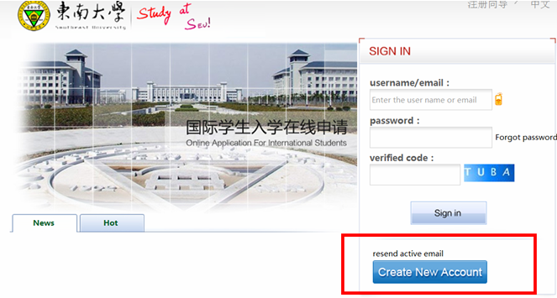
2、完成注册项填写，同意注册协议后点击注册按钮完成注册操作。
After finishing the register information, click "Agreement".
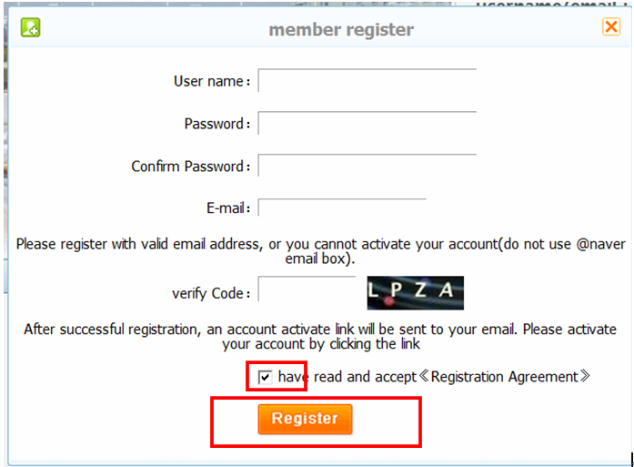

3. 根据提示进入注册邮箱，接收激活邮件并点击激活按钮使注册账户生效。
Register successfully and then activate the account.

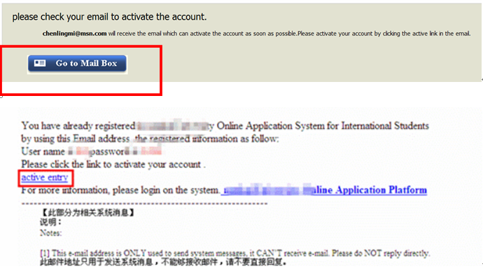

4、进入系统，回到首页
Enter the system, return to homepage.
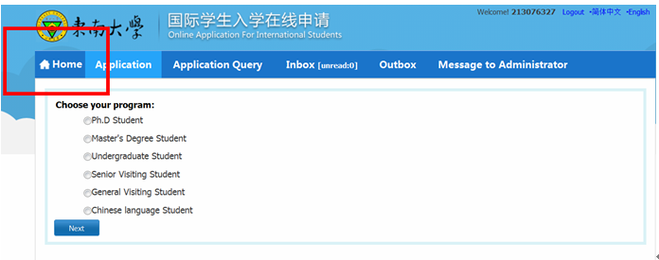

5、点击成绩查询，绑定学号、生日、国籍,
Click “QUERY RESULTS”, bind to your STUDENT ID NUMBER、BIRTH DATE and NATIONALITY

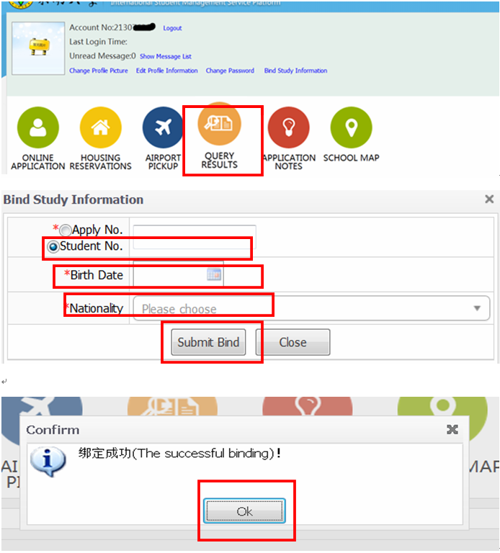

6、退出系统
Log out (You must log out then log in again.)

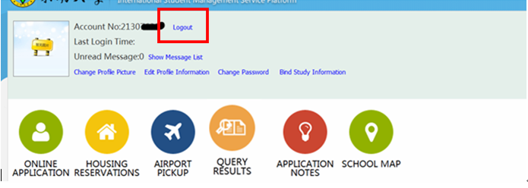

二、登录查询 Step two--Log in and Query results
1、登录log in
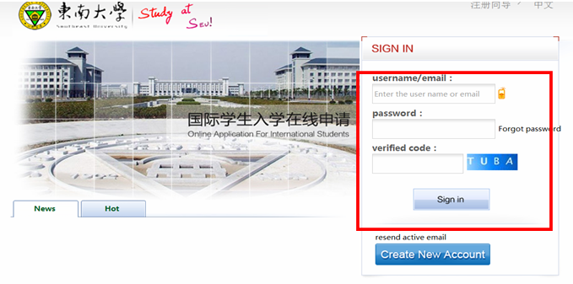
2、成绩查询Query results

