Annex 1:
CSC系统操作流程
CSC System Operating Procedures
- 登录CSC系统 ，log in to the CSC portal（https://studyinchina.csc.edu.cn/?9FyBl6JDFLTe=1682563276913#/login）
- 通过CSC号和自己设置的密码登录信息系统，若忘记密码，请点击下方“忘记密码”，并通过注册系统时的电子邮箱找回密码。
Log in the information system with your CSC number and password. Please click "Forgot password" and retrieve the password with your previously registered email address if you cannot remember the password.
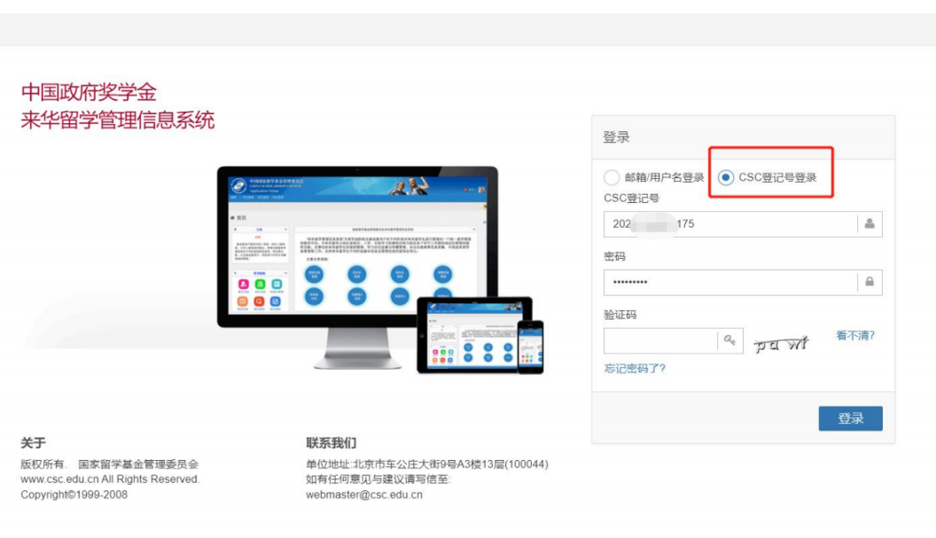
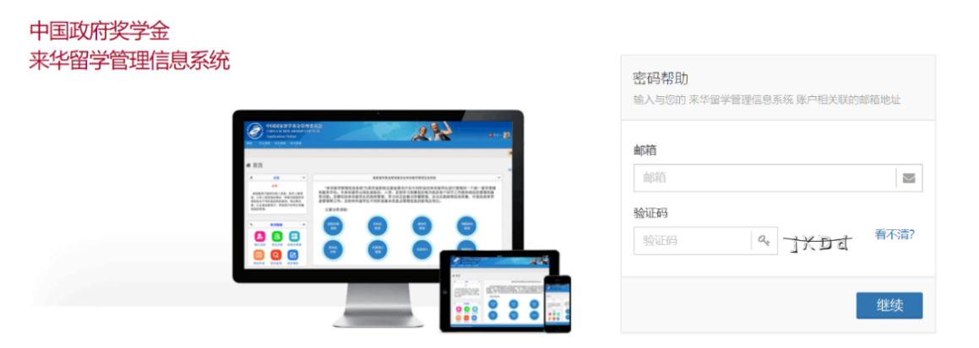
- 选择“奖学金年度自评”。
Choose "Annual review of scholarship".
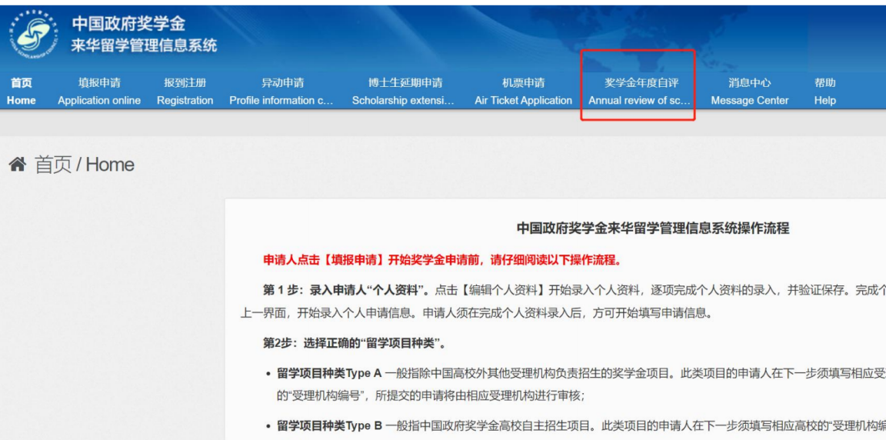
- 填写相关内容，上传成绩单等附件信息。
Fill in relevant content, upload transcripts and other attachments.
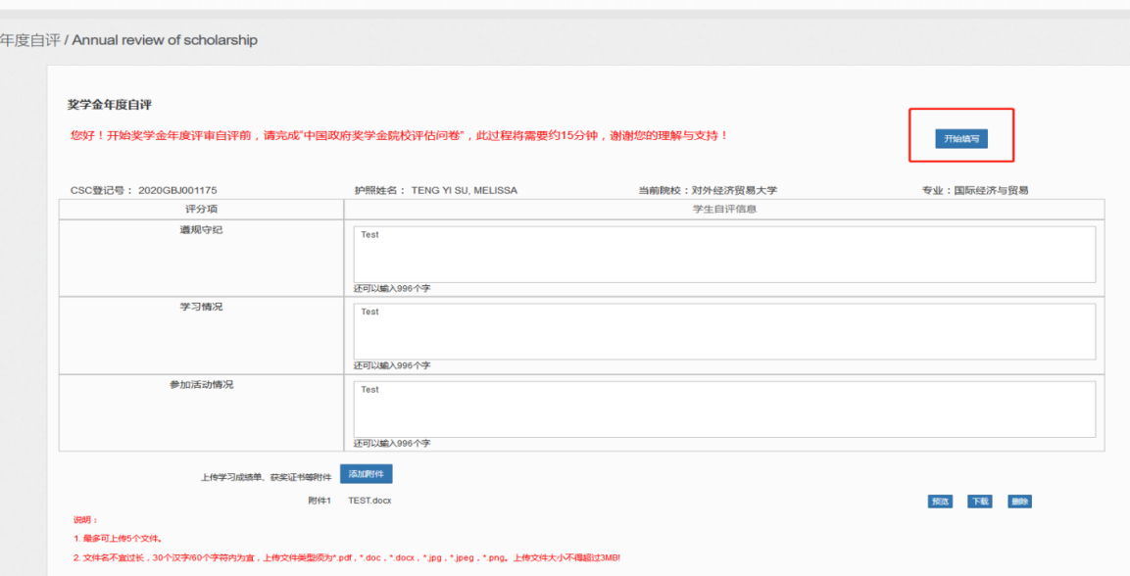
- 填写完成并上传附件后，勾选承诺条款，点击提交。
After filling in all the information and uploading the attachments, check the commitment terms and click Submit.
